# 

# Assignment 2 Report

**Code I Created**

OscarController:

* Update()
  + Walk left/right/not at all
  + Jump
  + Air Dash
  + Water jet propulsion
  + Grounded checks
* ClaimFire()
  + Remove Water/add Fire
* ClaimWater()
  + Remove Fire/add Water

FireballPhysics:

* OnTriggerEnter2D()
  + Ignore player, destroy enemy and self

PollenPhysics:

* OnTriggerEnter2D()
  + Ignore enemy, respawn player, destroy self

Enemy:

* Start()
  + Infinitely repeat ShootPollen()
* ShootPollen()
  + Instantiate pollen prefab
* Die()
  + Enemy is destroyed

StageSelect:

* startGame()
  + Load first stage
* endGame()
  + Quit application

EndLevel:

* OnCollisionEnter2D()
  + Load win screen when end reached

WaterPool:

* OnTriggerEnter2D()
  + When player touches, absorb water

Lantern:

* OnTriggerEnter2D()
  + When player touches, absorb fire

UIController:

* Precondition:
  + set icon locations
* Start()
  + Find player object and set Controller
* Update()
  + Update fire and water icons if PC has the right powers

**Code I Sourced/Modified**

OscarController:

* Flip()
  + Flip the sprite – Nick Hwang (<https://www.youtube.com/watch?v=ccxXxvlS4mI>)
* Die()
  + 1-line respawn – BurgZerg Arcade (<https://www.youtube.com/watch?v=Qn8tJhnY3eI>)

FireballPhysics:

* Prepare()
  + Initial velocity – Brackey (<https://www.youtube.com/watch?v=wkKsl1Mfp5M>)
  + Sprite flip – Nick Hwang (<https://www.youtube.com/watch?v=ccxXxvlS4mI>)

PollenPhysics:

* Start()
  + Initial velocity – Brackey (<https://www.youtube.com/watch?v=wkKsl1Mfp5M>)

KillPlayer:

* OnCollisionEnter2D()
  + Simple respawn – BurgZerg Arcade (<https://www.youtube.com/watch?v=Qn8tJhnY3eI>)

**Assets I Created**

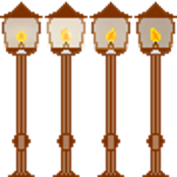The following sprites are entirely custom-made, with no particular source of reference. **All** spritesheets and tilesets were created using paint.net, and all animations were created using the Unity Animation Editor:

Created the Lantern spritesheet and animation



Created the Water Pool tileset

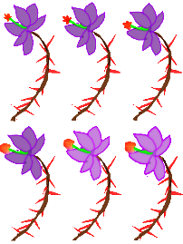

Created the Poison Rose spritesheet and animation.

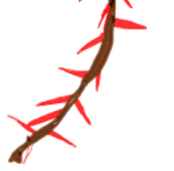

Created the Poison Thorn sprite.

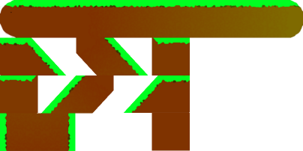

Created the Ledge tileset.



Created the Pollen sprite (Gradient, Crystallise and Gaussian blur)



Created the UI Icon spritesheet



Created the Fireball sprite

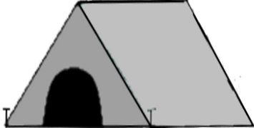

Created the Tent sprite

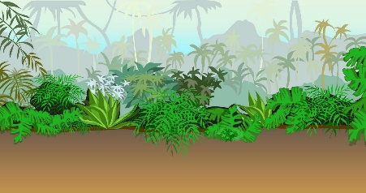Assets I Sourced/Modified

The background used for Stage 1 is an unchanged open-source jungle background.  
(<https://clipartstation.com/wp-content/uploads/2017/11/jungle-background-clipart-13.jpg> - no author given)

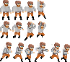

The player character is a heavily modified version of the *Animated Pixel Adventurer* spritesheet by rvros. (<https://rvros.itch.io/animated-pixel-hero>)

The custom font used in the Title Screen and Win Screen is the *Atiba* font by Ozan Karakoc (<https://www.1001freefonts.com/atiba.font>)

The BGM for Stage 1 is *Chee Zee Jungle* by Kevin McLeod (<https://incompetech.com/music/royalty-free/?keywords=chee+zee+jungle>)